Empathy Map Canvas
Project Name: AI-Powered Job Recruitment & Candidate Management System
An empathy map helps understand the needs, challenges, thoughts, and behaviors of users involved in the recruitment process. It allows the team to design a solution based on the actual problems faced by recruiters, hiring managers, candidates, and HR administrators.
Target Users
- Recruiters
- Hiring Managers
- Job Applicants/Candidates
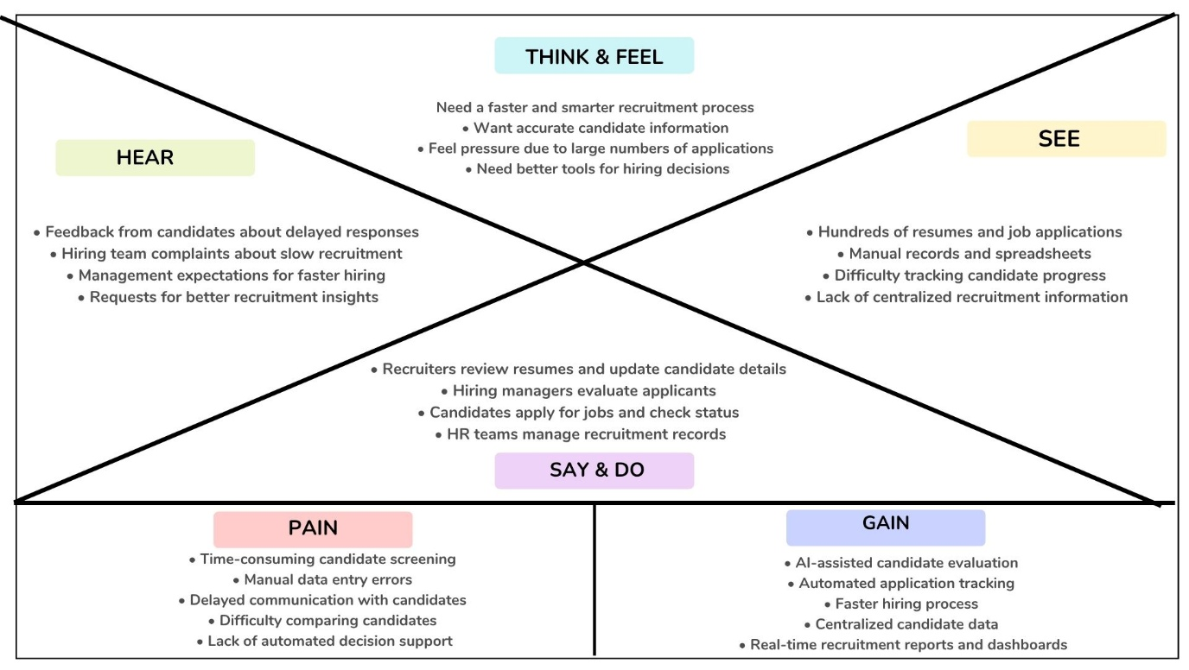
- HR Administrators

User Goals
User | Goals
Recruiter | Find suitable candidates quickly and manage recruitment activities efficiently.
Hiring Manager | Make accurate hiring decisions using candidate insights and reports.
Candidate | Apply easily and receive timely updates about application status.
HR Administrator | Maintain organized recruitment records and monitor hiring performance.

